Task
You are to measure the field of a small bar magnet (dipole) with the magnetic field sensor of your smartphone. You should also determine the strength of the earth's magnetic field and the angle of inclination.
Material
Smartphone or tablet with App Phyphox, ruler (e.g. "folding rule", tape measure), small rod magnet (max. 5cm); and if possible: compass, double logarithmic mm paper
Theoretical background and technical information
Some of the experiments in this worksheet were originally developed at the Geoforschungszentrum Potsdam during a workshop on the geomagnetic field. Note: Magnets for office use often do not have a reasonable dipole field and may not be usable. IMPORTANT: All measurements are very sensitive. Therefore, it is important to make sure that there are no other sources of magnetic interference in the working environment (iron, steel e.g. in the table; electric cables etc.). It is recommended to set the smartphone to flight mode. Disclaimer: Since smartphones contain non-magnetic storage media, small magnets cannot in principle cause any damage to the device. Caution: very strong magnetic fields can damage the mechanical parts of the smartphone (e.g. speakers). It may happen that the magnetic field sensor of the smartphone recalibrates itself when it measures an unusually strong field. If your measurement appears to be unreasonable, recalibrate the device by swivelling it back and forth in a figure of eight.
Implementation
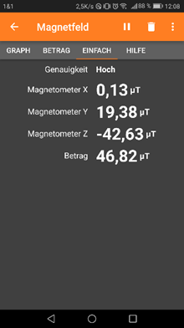
Fig. 1 Phyphox App shows X, Y, Z - components and magnitude of field strength B (from GFZ Potsdam, CC BY SA)
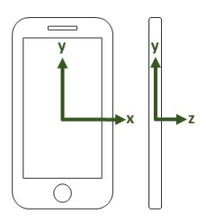
Directions of the X, Y, Z - Components of the Phyphox App (phyphox.org, CC BY SA)
- Set your smartphone to flight mode and start the magnetometer app. Place the device on a straight, non-magnetic surface (e.g. wooden table or floor). Test if you are non-magnetic. Does the display change when you move? Do your glasses, ballpoint pen, belt buckle etc. have an influence on the measurement?

- Now align the device to the north by rotating it on the table level. The display value of the X-component of the magnetometer is then zero (see Fig. 1). Compare with a compass if possible. Make a note of the display values.
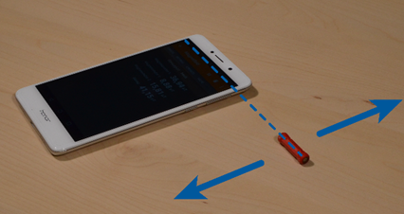 | 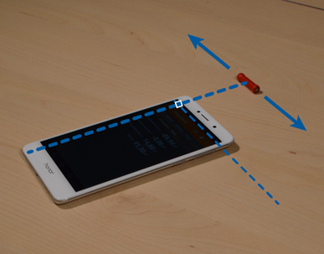
Fig. 2a An EW aligned magnet is moved in the NS direction. (from GFZ Potsdam, CC BY SA) | Fig. 2b An EW aligned magnet is moved in EW direction. (from GFZ Potsdam, CC BY SA)
- First, the position of the magnetic field strength sensor in the smartphone must be determined. For this purpose, the smartphone is still oriented to the north and a magnet is placed next to the smartphone while the magnetic field measurement is running (see Fig. 2).
If the maximum magnetic field strength is displayed, the magnet is exactly at the height of the sensor, where the position can now be marked, for example with adhesive tape. Write down the make and model of your cell phone and make a sketch of the position of the sensor.

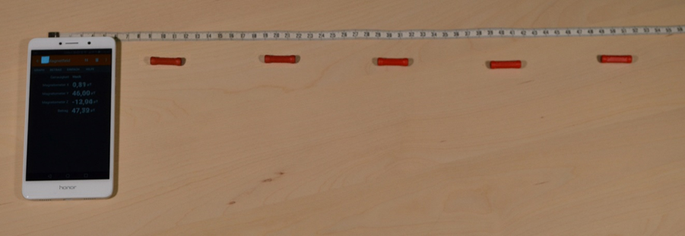
Fig. 3 Determination of the field strength as a function of the distance to the magnet (from GFZ Potsdam, CC BY SA)
- Approach the bar magnet from the east (or west) of the smartphone (Fig. 3). The magnetic dipole points in EW direction (NS direction gives no signal). Measure the distance r between magnet center and sensor. Create a table as in the example. Measure at reasonable distances, e.g. 5 cm each.
r in m | 0,50 | 0,40 | 0,30 | 0,20 | 0,10
Bx in µT | 1,5 | 3,0 | 7,5 | 27 | 200
- Now approach the magnets from the north (in the axis through the sensor) to the smartphone. The magnetic dipole points again in EW direction (NS direction gives no signal). Again, take a series of measured values. E.G.
r in m | 0,50 | 0,40 | 0,30 | 0,20 | 0,10
Bx in µT | 0,5 | 1,5 | 3,0 | 13 | 100

Evaluation
To a) Calculate the angle of inclination from the Y- and Z-component of the B-field vector $α=\tan^{-1}\left(\frac{B_{z}}{B_{y}}\right)$. Draw the course of the B-field in your laboratory.
Compare your measured values with those of the Physikalisch-Technische Bundesanstalt.
https://www.ptb.de/cms/nc/ptb/fachabteilungen/abt2/fb-25/ag-251/live-daten-erdmagnetfeldmessung.html

To d) and e) draw a B_{x}(r) diagram each. Which functional course do you suspect? Confirm by comparing the measured values that at the same distance the magnetic field of a dipole in the direction of the dipole axis is twice as strong as perpendicular to it ("Gaussian main positions"). Make a sketch with the field lines of your bar magnet.
Draw the two diagrams also with double logarithmic plotting (example appendix). Calculate the slope k. This is the exponent of the corresponding power function. Specify the functions equation.

Voluntary:
- Show that from a potency function $y=b_{0}∙x^{k}$ by logarithmizing a linear function with the increase $k$ results. Explain the meaning of the pre-factor $b_{0}$.

- A current-carrying conductor loop also generates a magnetic field similar to that of the bar magnet; both have a magnetic dipole moment $µ$. At a point P at a distance $r$ along the central axis of the dipole the field is parallel to the axis and has the field strength $\vec{B}\left(r\right)=\frac{µ_{0}}{2π} \frac{\vec{µ}}{r³}$ where $µ_{0}$ is the magnetic field constant. (This formula only applies if $r$ is much larger than the dimension of the dipole or loop. See Halliday physics 1st edition, Wiley-VCH, 203, p.854f. )

- Determine the magnetic dipole moment for your bar magnet from your measurement.

